High Frequency Radio System Shore (HFRS-S)

HF ARCHITECTURE

Approved by:
James A. Kermitz, USCG
ESD-RFCB-LRC Shore Engineering Lead

Record of Changes
Change No. | Date | Title or Brief Description | Entered By
1.0 Original | 14Oct2025 | HFRS-S HF Shore Architecture v1.0 | James Kermitz

Table of Contents
Section 1: Scope 2
1.1 Document Overview 2
1.2 Identification 2
Section 2: System Overview 3
2.1 Interface Design 3
2.2 4KW Interface Design. 3
2.3 1KW COTHEN Interface Design 4
2.4 4KW COTHEN Interface Designs 5
2.5 Physical Interface 7
Section 3: Physical Interface Description Coast Guard Owned COTHEN Connected Transmitters 11
3.1 RF Interface, Transmitter Antenna Interface (TAM) 11
3.2 Audio and keyline Interface 11
3.3 Serial Control Interface 11
Section 4: Interface Testing and Evaluation 12

List of Figures

Figure 1-1 Simplified HF System Interface Diagram 4
Figure 2.-1 4KW HF System Interface Design 5
Figure 2-2 1KW COTHEN Interface Design 6
Figure 2-3 Typical Single 4KW COTHEN Split Site Interface Design 7
Figure 2-4 Typical Two 4KW COTHEN Split Site Interface 8

Scope

Document Overview
This document is divided into 2 sections. Section 1, Scope, which provides a high-level overview of the High Frequency (HF) communications systems shore interface. Section 2, Interface Design, which provides a detailed description and diagram of the physical interfaces between the HF transmitters, receivers, transceivers and various shore infrastructures.

Identification
The United States Coast Guard (USCG) utilizes HF transmitters, receivers and transceiver systems that interface with shore subsystems to provide HF long-range communications in the 2.0MHz-30MHz frequency spectrum. They provide interoperability with other USCG assets, mission partners (DoD, NATO, DHS, etc.) and state and civilian entities. There are 3 configurations covered in this HF Architecture document.

System Overview
This HF Architecture specifies the interfaces between the transmitters, receivers and transceivers to shore components, power sources and third-party Communications Management System (CMS) installed at CG COMMCOM, Remote Communication Facilities (RCF) and RCF COTHEN sites, these interfaces include various shore Radio Frequency (RF), Audio Frequency (AF), keyline Push-to-Talk (PTT) and automated distribution subsystems. It describes the physical interfaces, signal flow to and from the equipment, and signals required to transmit/receive HF RF external to the site. A simplified interface diagram is shown below in Figure 1-1:

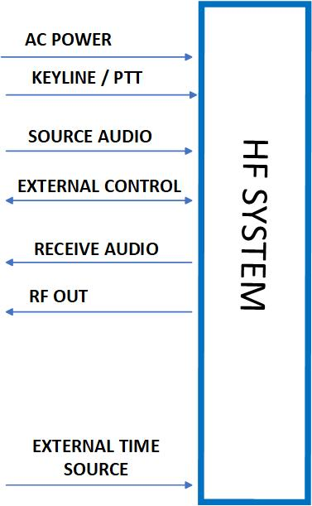
Figure 1-1 Simplified HF System Interface Diagram

Interface Design

4KW Interface Design.
The current transmitter, AN/URG-III(V1), is installed at CG COMMCOM and six RCF’s locations: Boston, Miami, New Orleans, Pt Reyes, Kodiak, Honolulu.
Figure 2-1 shows a typical interface between a single 4KW transmitter at CG COMMCOM and the six RCF’s. The transmitter exciter and Transmitter Antenna Matrix (TAM) interfaces via RS-232 with Communications Station Automation System (CSAS) for control on CG1 network and Communications System Network (CSN) for audio on Verizon network. The Transmitter Antenna Matrix (TAM) interfaces to various broadband antennas via RF cables.

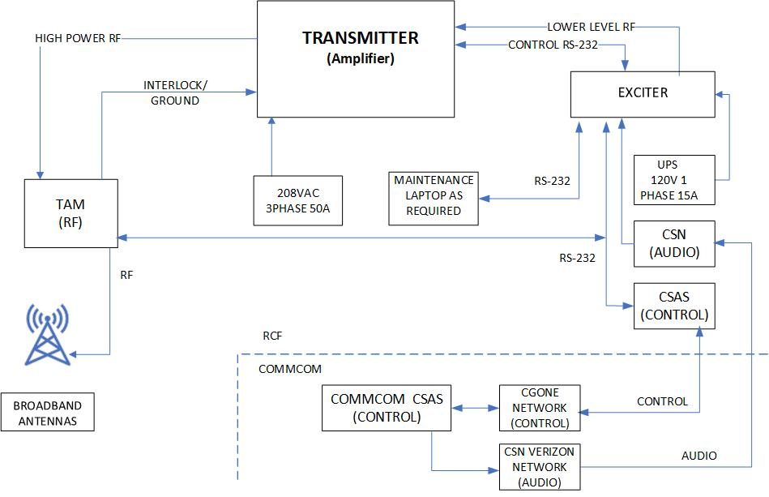
Figure 2.-1 4KW HF System Interface Design

1KW COTHEN Interface Design
The AN/URG-III(V2) system is installed at the following Alaskan RCF sites: Sheyma, St. Paul, Cold Bay, Nome, Pt. Higgins and Kodiak. Kodiak BLDG 546 has a single transmitter configuration.
Figure 2-1 shows the interfaces between two 1KW transmitters at the above RCF’s. The transmitters interfaces with Custom Border Patrol (CPB) Customs Over The Horizon Enforcement Network (COTHEN) and a maintenance laptop.

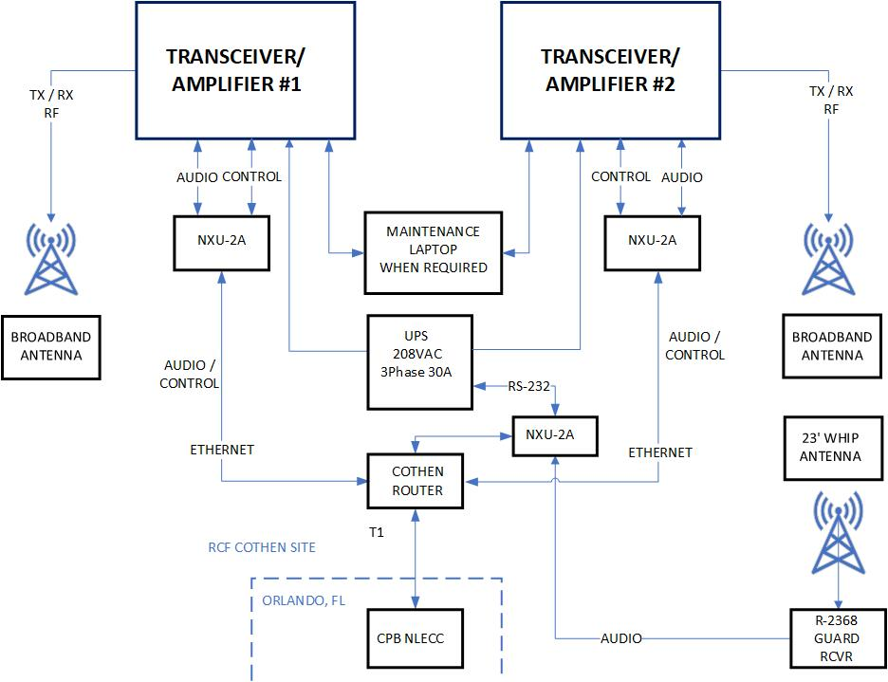
Figure 2-2 1KW COTHEN Interface Design

4KW COTHEN Interface Designs

Single transmitter design: RCF Boston, RCF PT. Reyes, RCF Honolulu.
Two transmitter design: RCF Kodiak, Guam

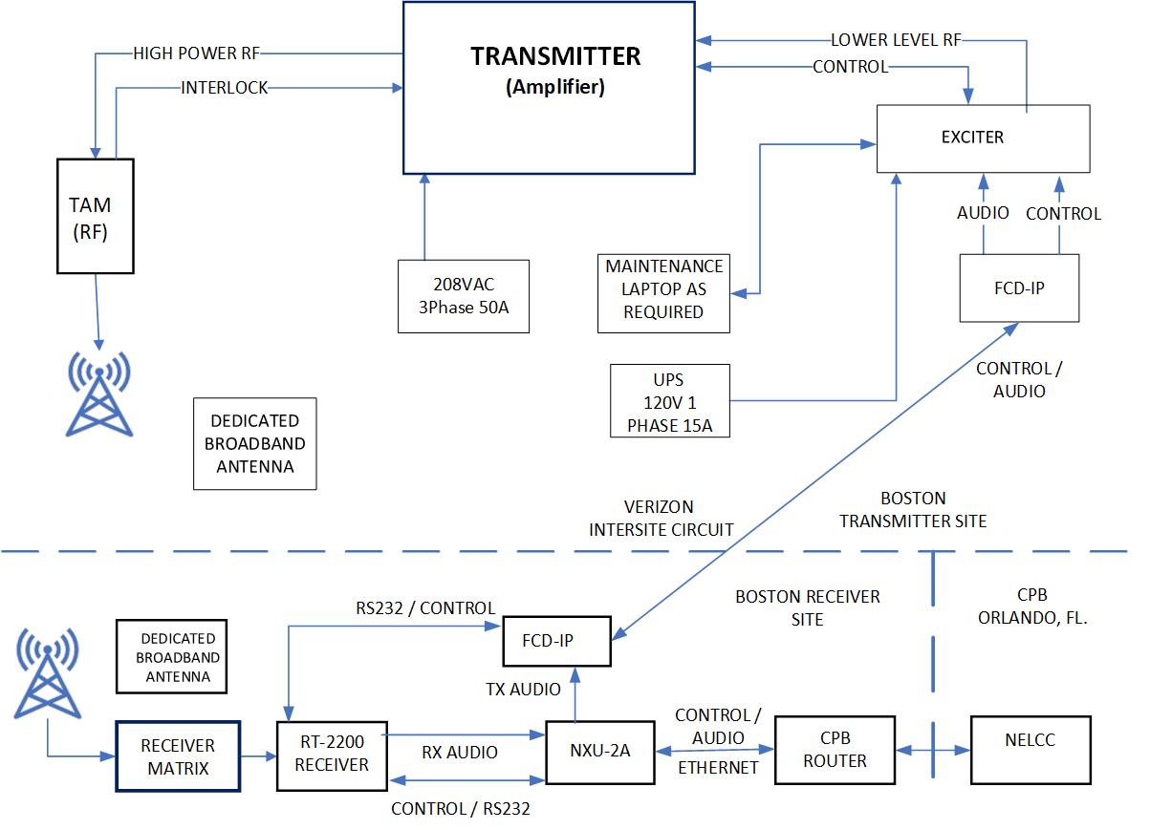
Figure 2-3 Typical Single 4KW COTHEN Split Site Interface Design

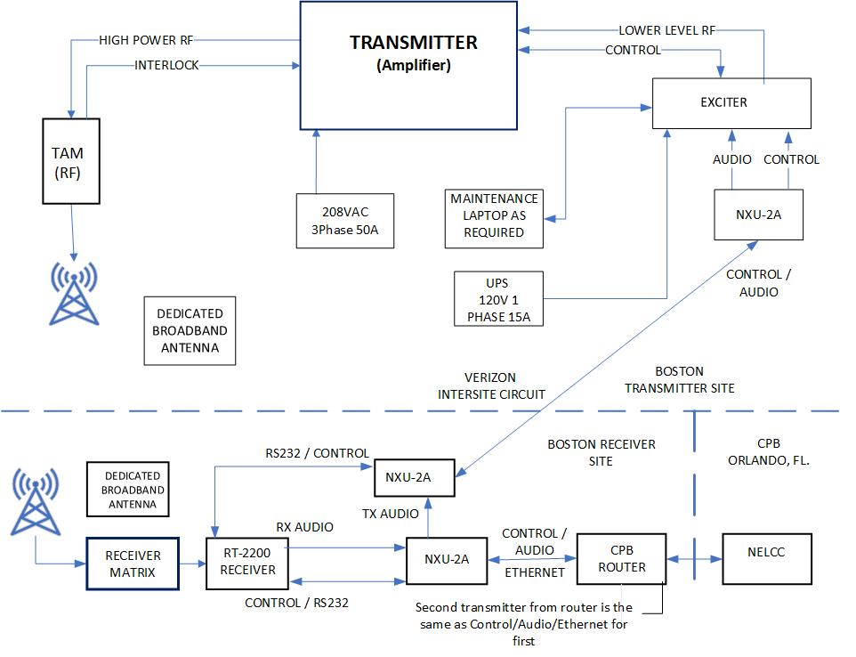
Figure 2-4 Typical Two 4KW COTHEN Split Site Interface

Physical Interface

Description Coast Guard Controlled Transmitters

2.5.1.1 RF Interface

1.5Mhz-30Mhz RF energy is transmitted by an HF broadband antenna of various manufactures. Connection from the transmitter to the antenna is made via a Delta Electronics SLS-4 RF Matrix. The SLS-4 uses EIA 1-5/8” input and output connectors. A mix of 1-5/8” and 3-1/8”dry air transmission line connect the SLS-4 to antennas.

2.5.1.2 Audio and keyline Interface
The receive audio leaves the RT-2200 and goes to the NXU-2 to be converted and transported as VOIP to the Custom Border Patrol owned Router for further transport to NELCC’s COTHEN control system. The transmit audio is received as VOIP from NELCC’s COTHEN control system and converted by the NXU-2-to-600-ohm audio and keyline to the exciter.

2.5.1.3 Control Interface
Transmitter control follows the same routing as the Audio/Keyline as a VOIP signal and gets converted from digital to serial by the NXU-2.

Physical Interface Description Coast Guard Owned COTHEN Connected Transmitters

RF Interface, Transmitter Antenna Interface (TAM)
1.5Mhz-30Mhz RF energy is transmitted and received by an HF broadband antenna of various manufactures. Connection from the transmitter to the antenna is typically made via a balun.

Audio and keyline Interface
The 600-ohm audio and ground keyline take separate paths from CSN audio system. Audio is applied directly to exciter input, processed and set to the amplifier as low-level RF. A parallel path goes to a VOX interface device and when audio is present passes a key signal (ground) to the exciter to key the system.

Serial Control Interface
All transmitter control for Coast Guard connected transmitters is control via Communication Station Automation System (CSAS). This is a Coast Guard designed software that controls all COMSYS equipment via RS-232 commands.

Interface Testing and Evaluation
All testing shall be performed and documented in accordance with the HFR-S Test and Evaluation Master Plan (TEMP). These interfaces may be verified with a dedicated test procedure or as part of another test procedure. At a minimum, the interface between receive/transmit RF from the RF distribution system, the transmit AF audio path and receive audio path will be tested to ensure system functionality.

